**Padre Conceicao College of Engineering**

**Department of Computer Engineering**

**Sem:** V

**Academic Year:** 2022-23 **Date:** 14/12/2022

**DBMS&QP LAB MINI PROJECT SYNOPSIS**

**Title:- Online Food Ordering**

**Abstract:-**

This **Online Food Ordering System** project in PHP focuses mainly on managing online food orders. To be more precise, the system helps to keep track of clients, and their orders. Also, the system displays all the available food dishes with their respective restaurants. In addition, the system allows online bookings for the client. Evidently, this project contains a client-side with an admin panel. In an overview of this web application, customers have to register in order to use the services. Here, customers can view food dishes and filter restaurants. In terms of food ordering, he/she can simply add dishes to the cart and checkout. All these customers’ activities take place on the client side which also allows user to view their order list with status. The customers can delete orders anytime.

#### Admin Panel

An administrator has full control over the system. He/she can manage customers, orders, restaurants, categories, food menu, and so on. Here, each and every section has its own respective details such as name, image, and other important details. Here, an admin first has to set up details for restaurants and categories for maintaining further processes. Category simply refers to a type of restaurant such as continental, Italian food, etc. For the registration of a restaurant, the user has to provide a number of details. This includes the name of the restaurant, website, opening hours,etc information.The above-mentioned features are only allowed to be performed by the admin.

#### Food Menu Management

The administrator can manage all the food menus/dishes for the system. In order to add food dishes, the user has to provide details such as name, description, price, image, and select available restaurants. For this section, it is a must that the system should contain a number of restaurant records. In fact, each restaurant represents different food items to the customers on the client-side. With this, the customers can simply filter food items as the dishes vary according to different restaurants. To be more precise, this whole system somehow works like an e-commerce site looking after its workflow. Also, the customers can view the top 6 featured or the latest dishes on the client-side landing page.

##### Available Features:

1.Filter Food Items

2.Filter Restaurants

3.Order Foods

4.Add to cart system

5.View personal orders

6.Restaurant Management

7.Food Category Management

8.Food Menu Management

9.Manage Food Orders

10.Cancel Orders

11.Customer Management

12.Total Earnings

**Objectives:**

1. Add different restraunts.

2. Add resteraunt categories.

3. Add user orders.

4. Add different menus for different resteraunts.

5. View user orders.

6. View order bills.

7. View different resteraunts.

8. View different categories of different resteraunts.

9. Update and delete different values of orders status,resteraunts,categories,etc details

and information.

**Padre Conceicao College of Engineering**

**Department of Computer Engineering**

**Table Design:**

The database contains 6 tables:

1. Admin
2. Dishes
3. Remark
4. Restaurant
5. Res_category
6. User
7. User_orders

**System Requirements:-**

• Front End Tools:- HTML, CSS, PHP

• Back End Tools:- MySQL

|  |  |  |
| --- | --- | --- |
| **Team Details :** | | |
| **Sr.No** | **Roll No** | **Name of Students** |
| **1** | **20CE21** | **Edrich Ryan Cardozo** |
| **2** | **20CE** |  |
| **3** | **20CE** |  |

**Padre Conceicao College of Engineering**

**Department of Computer Engineering**

**ER Diagram :**

**Padre Conceicao College of Engineering**

**Department of Computer Engineering**

**Schema Diagram:**

**Online Food Ordering**

**Admin table :**

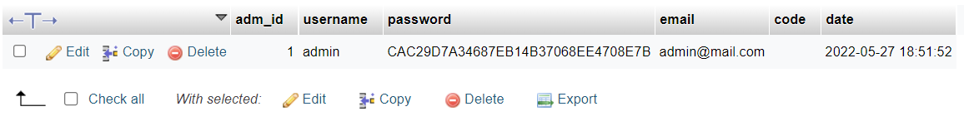

**Dishes table :**

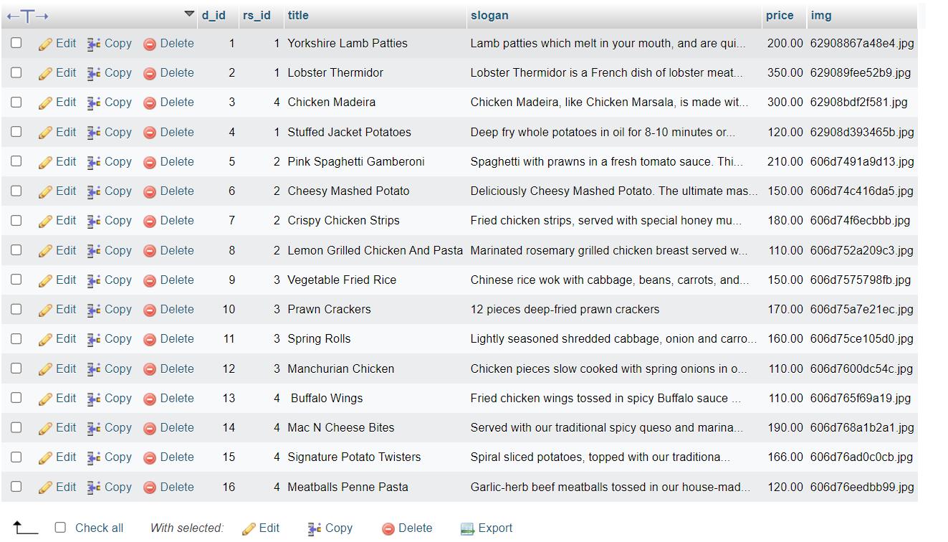

**Remark table:**

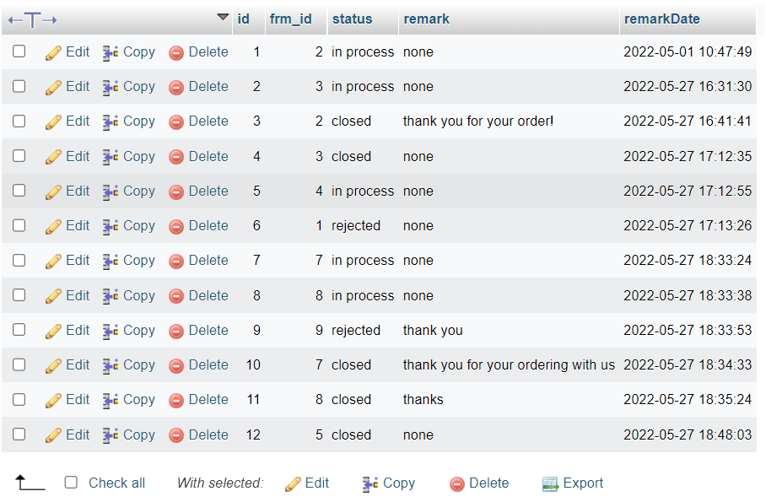

**Restaurant table:**

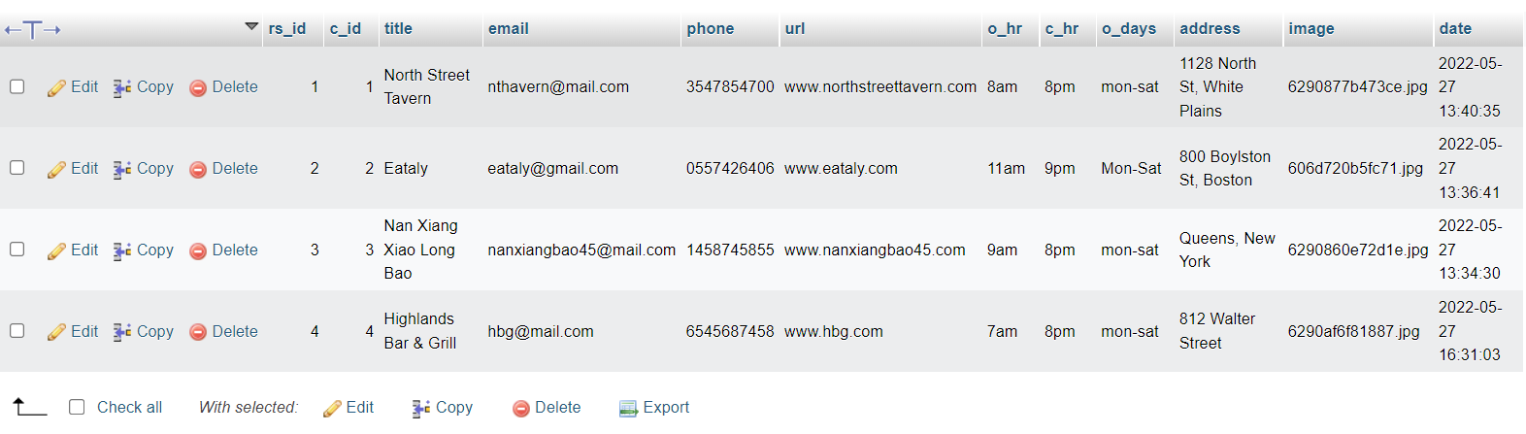

**Res_category table:**

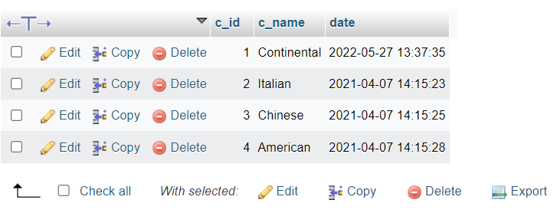

**User table:**

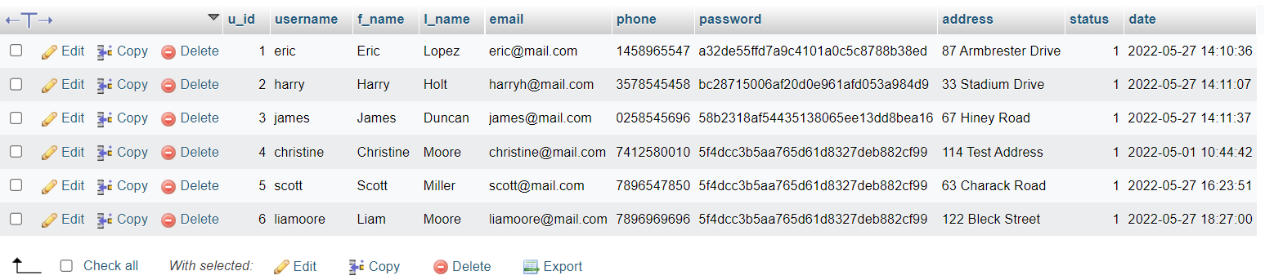

**User_orders table :**

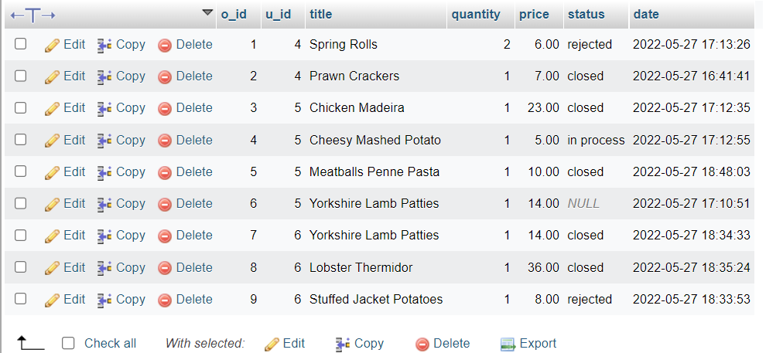

**INDEX.PHP**

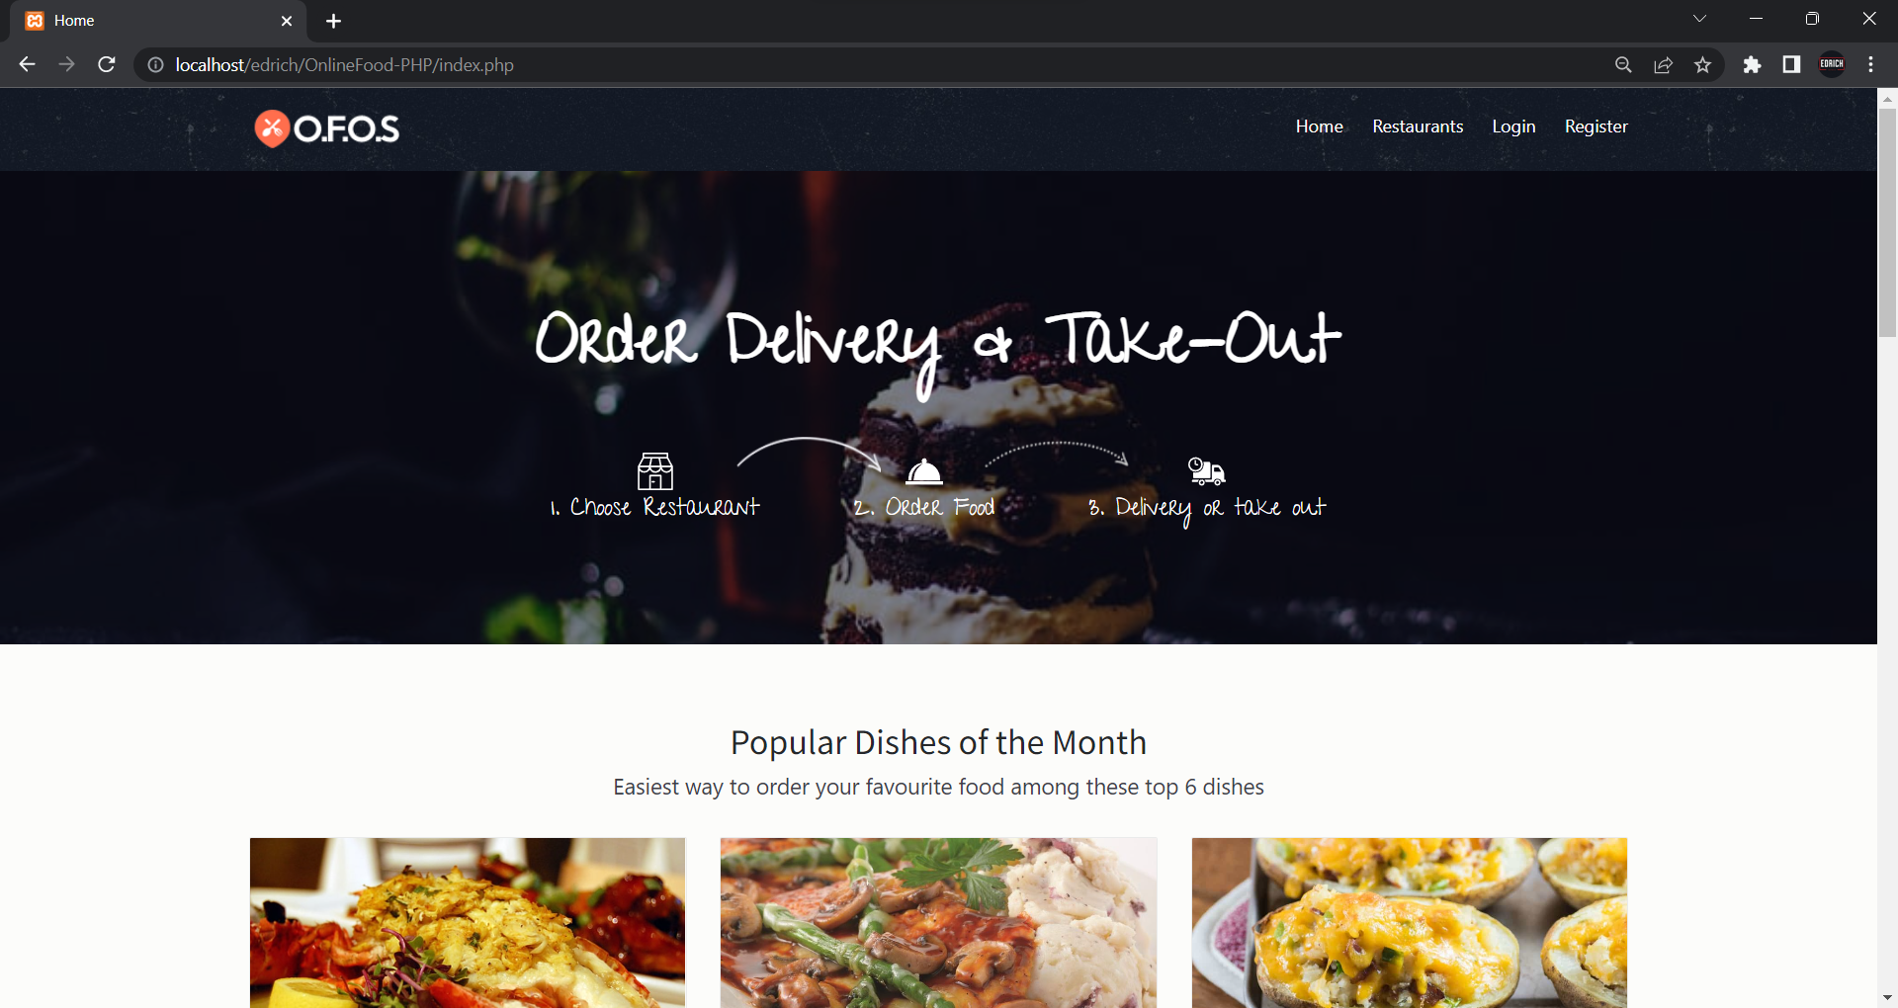

<!DOCTYPE html>

<html lang="en">

<?php

include("connection/connect.php");

error_reporting(0);

session_start();

?>

<head>

<meta charset="utf-8">

<meta http-equiv="X-UA-Compatible" content="IE=edge">

<meta name="viewport" content="width=device-width, initial-scale=1, shrink-to-fit=no">

<meta name="description" content="">

<meta name="author" content="">

<link rel="icon" href="#">

<title>Home</title>

<link href="css/bootstrap.min.css" rel="stylesheet">

<link href="css/font-awesome.min.css" rel="stylesheet">

<link href="css/animsition.min.css" rel="stylesheet">

<link href="css/animate.css" rel="stylesheet">

<link href="css/style.css" rel="stylesheet"> </head>

<body class="home">

<header id="header" class="header-scroll top-header headrom">

<nav class="navbar navbar-dark">

<div class="container">

<button class="navbar-toggler hidden-lg-up" type="button" data-toggle="collapse" data-target="#mainNavbarCollapse">&#9776;</button>

<a class="navbar-brand" href="index.php"> <img class="img-rounded" src="images/icn.png" alt=""> </a>

<div class="collapse navbar-toggleable-md float-lg-right" id="mainNavbarCollapse">

<ul class="nav navbar-nav">

<li class="nav-item"> <a class="nav-link active" href="index.php">Home <span class="sr-only">(current)</span></a> </li>

<li class="nav-item"> <a class="nav-link active" href="restaurants.php">Restaurants <span class="sr-only"></span></a> </li>

<?php

if(empty($_SESSION["user_id"])) // if user is not login{

echo '<li class="nav-item"><a href="login.php" class="nav-link active">Login</a> </li>

<li class="nav-item"><a href="registration.php" class="nav-link active">Register</a> </li>';}

else{

echo '<li class="nav-item nav-link active">Hi,'.$_SESSION["user_id"].'</li>';

echo '<li class="nav-item"><a href="your_orders.php" class="nav-link active">My Orders</a> </li>';

echo '<li class="nav-item"><a href="logout.php" class="nav-link active">Logout</a> </li>';

}?>

</div></div> </nav>

</header>

<section class="hero bg-image" data-image-src="images/img/pimg.jpg">

<div class="hero-inner">

<div class="container text-center hero-text font-white">

<h1>Order Delivery & Take-Out </h1>

<div class="banner-form">

<form class="form-inline">

</form>

</div>

<div class="steps">

<div class="step-item step1">

<svg xmlns="http://www.w3.org/2000/svg" viewbox="0 0 483 483" width="512" height="512">

<g fill="#FFF">

</svg>

<h4><span style="color:white;">1. </span>Choose Restaurant</h4> </div>

<div class="step-item step2">

<svg xmlns="http://www.w3.org/2000/svg" width="512" height="512" viewbox="0 0 380.721 380.721"> </svg>

<h4><span style="color:white;">2. </span>Order Food</h4> </div>

<div class="step-item step3">

<svg xmlns="http://www.w3.org/2000/svg" width="512" height="512" viewbox="0 0 612.001 612">

<h4><span style="color:white;">3. </span>Delivery or take out</h4> </div> </div> </div>

</div> </section>

<section class="popular"><div class="container">

<div class="title text-xs-center m-b-30">

<h2>Popular Dishes of the Month</h2>

<p class="lead">Easiest way to order your favourite food among these top 6 dishes</p>

</div>

<div class="row">

<?php

$query_res= mysqli_query($db,"select * from dishes LIMIT 6");

while($r=mysqli_fetch_array($query_res)) {

echo ' <div class="col-xs-12 col-sm-6 col-md-4 food-item">

<div class="food-item-wrap">

<div class="figure-wrap bg-image" data-image-src="admin/Res_img/dishes/'.$r['img'].'"></div>

<div class="content">

<h5><a href="dishes.php?res_id='.$r['rs_id'].'">'.$r['title'].'</a></h5>

<div class="product-name">'.$r['slogan'].'</div>

<div class="price-btn-block"> <span class="price">Rs'.$r['price'].'</span> <a href="dishes.php?res_id='.$r['rs_id'].'" class="btn theme-btn-dash pull-right">Order Now</a> </div>

</div> </div> </div>';

}?> </div> </div> </section>

<section class="how-it-works"> <div class="container">

<div class="text-xs-center">

<h2>Easy to Order</h2>

<div class="row how-it-works-solution">

<div class="col-xs-12 col-sm-12 col-md-4 how-it-works-steps white-txt col1">

<div class="how-it-works-wrap">

<div class="step step-1"> <div class="icon" data-step="1">

<svg xmlns="http://www.w3.org/2000/svg" viewbox="0 0 483 483" width="512" height="512">

<g fill="#FFF">

>

</svg>

</div>

<h3>Choose a restaurant</h3>

<p>We"ve got your covered with menus from a variety of delivery restaurants online.</p>

</div>

</div>

</div>

<div class="col-xs-12 col-sm-12 col-md-4 how-it-works-steps white-txt col2">

<div class="step step-2">

<div class="icon" data-step="2">

<svg xmlns="http://www.w3.org/2000/svg" width="512" height="512" viewbox="0 0 380.721 380.721">

<g fill="#FFF">

</svg>

</div>

<h3>Choose a dish</h3>

<p>We"ve got your covered with a variety of delivery restaurants online.</p>

</div>

</div>

<div class="col-xs-12 col-sm-12 col-md-4 how-it-works-steps white-txt col3">

<div class="step step-3">

<div class="icon" data-step="3">

<svg xmlns="http://www.w3.org/2000/svg" width="512" height="512" viewbox="0 0 612.001 612">

</div>

<h3>Pick up or Delivery</h3>

<p>Get your food delivered! And enjoy your meal! </p>

</div>

</div></div> </div>

<div class="row">

<div class="col-sm-12 text-center">

<p class="pay-info">Cash on Delivery</p>

</div>

</div>

</div>

</section>

<section class="featured-restaurants">

<div class="container">

<div class="row">

<div class="col-sm-4">

<div class="title-block pull-left">

<h4>Featured Restaurants</h4> </div>

</div>

<div class="col-sm-8">

<div class="restaurants-filter pull-right">

<nav class="primary pull-left">

<ul>

<li><a href="#" class="selected" data-filter="*">all</a> </li>

<?php

$res= mysqli_query($db,"select * from res_category");

while($row=mysqli_fetch_array($res)) {

echo '<li><a href="#" data-filter=".'.$row['c_name'].'"> '.$row['c_name'].'</a> </li>';

}?> </ul> </nav> </div> </div> </div>

<div class="row">

<div class="restaurant-listing">

<?php

$ress= mysqli_query($db,"select * from restaurant");

while($rows=mysqli_fetch_array($ress))

$query= mysqli_query($db,"select * from res_category where c_id='".$rows['c_id']."' ");

$rowss=mysqli_fetch_array($query); echo ' <div class="col-xs-12 col-sm-12 col-md-6 single-restaurant all '.$rowss['c_name'].'"> <div class="restaurant-wrap"><div class="row">

<div class="col-xs-12 col-sm-3 col-md-12 col-lg-3 text-xs-center">

<a class="restaurant-logo" href="dishes.php?res_id='.$rows['rs_id'].'" > <img src="admin/Res_img/'.$rows['image'].'" alt="Restaurant logo"> </a> </div>

<div class="col-xs-12 col-sm-9 col-md-12 col-lg-9">

<h5><a href="dishes.php?res_id='.$rows['rs_id'].'" >'.$rows['title'].'</a></h5> <span>'.$rows['address'].'</span>

</div> </div> </div> </div>';}?>

</div>

</div>

</div>

</section>

<footer class="footer">

<div class="container">

<div class="bottom-footer">

<div class="row">

<div class="col-xs-12 col-sm-3 payment-options color-gray">

<h5>Payment Options</h5>

<ul>

<li>

<a href="#"> <img src="images/paypal.png" alt="Paypal"> </a>

</li>

<li>

<a href="#"> <img src="images/mastercard.png" alt="Mastercard"> </a>

</li>

<li>

<a href="#"> <img src="images/maestro.png" alt="Maestro"> </a>

</li>

<li>

<a href="#"> <img src="images/stripe.png" alt="Stripe"> </a>

</li>

<li>

<a href="#"> <img src="images/bitcoin.png" alt="Bitcoin"> </a>

</li>

</ul>

</div>

<div class="col-xs-12 col-sm-4 address color-gray">

<h5>NAME</h5>

<p>Edrich Ryan Cardozo </p>

<h5>Roll number: 20CE21</a></h5> </div>

<div class="col-xs-12 col-sm-5 additional-info color-gray">

<h5>Addition informations</h5>

<p>Online Food Ordering DBMS project by 20CE21.</p>

</div>

</div>

</div></div>

</footer>

<script src="js/jquery.min.js"></script>

<script src="js/tether.min.js"></script>

<script src="js/bootstrap.min.js"></script>

<script src="js/animsition.min.js"></script>

<script src="js/bootstrap-slider.min.js"></script>

<script src="js/jquery.isotope.min.js"></script>

<script src="js/headroom.js"></script>

<script src="js/foodpicky.min.js"></script>

</body>

</html>

**LOGIN.PHP**

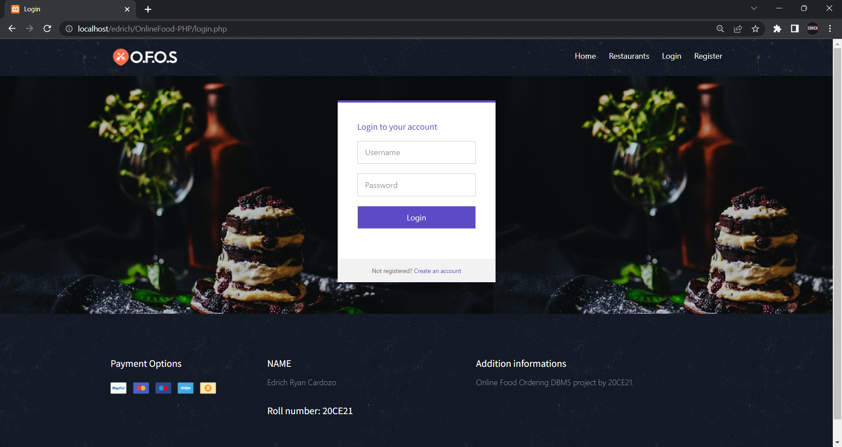

<!DOCTYPE html>

<html lang="en" >

<head>

<meta charset="UTF-8">

<title>Login</title>

<link rel="stylesheet" href="https://cdnjs.cloudflare.com/ajax/libs/meyer-reset/2.0/reset.min.css">

<link rel='stylesheet prefetch' href='https://fonts.googleapis.com/css?family=Roboto:400,100,300,500,700,900|RobotoDraft:400,100,300,500,700,900'>

<link rel='stylesheet prefetch' href='https://maxcdn.bootstrapcdn.com/font-awesome/4.3.0/css/font-awesome.min.css'>

<link rel="stylesheet" href="css/login.css">

<style type="text/css">

#buttn{

color:#fff;

background-color: #5c4ac7;

}

</style>

<meta name="viewport" content="width=device-width, initial-scale=1, shrink-to-fit=no">

<link href="css/bootstrap.min.css" rel="stylesheet">

<link href="css/font-awesome.min.css" rel="stylesheet">

<link href="css/animsition.min.css" rel="stylesheet">

<link href="css/animate.css" rel="stylesheet">

<link href="css/style.css" rel="stylesheet">

</head>

<body>

<header id="header" class="header-scroll top-header headrom">

<nav class="navbar navbar-dark">

<div class="container">

<button class="navbar-toggler hidden-lg-up" type="button" data-toggle="collapse" data-target="#mainNavbarCollapse">&#9776;</button>

<a class="navbar-brand" href="index.php"> <img class="img-rounded" src="images/icn.png" alt=""> </a>

<div class="collapse navbar-toggleable-md float-lg-right" id="mainNavbarCollapse">

<ul class="nav navbar-nav">

<li class="nav-item"> <a class="nav-link active" href="index.php">Home <span class="sr-only">(current)</span></a> </li>

<li class="nav-item"> <a class="nav-link active" href="restaurants.php">Restaurants <span class="sr-only"></span></a> </li>

<?php

if(empty($_SESSION["user_id"])){

echo '<li class="nav-item"><a href="login.php" class="nav-link active">Login</a> </li>

<li class="nav-item"><a href="registration.php" class="nav-link active">Register</a> </li>';

}

else{

echo '<li class="nav-item"><a href="your_orders.php" class="nav-link active">My Orders</a> </li>';

echo '<li class="nav-item"><a href="logout.php" class="nav-link active">Logout</a> </li>';}?>

</ul> </div> </div> </nav></header>

<div style=" background-image: url('images/img/pimg.jpg');">

<?php

include("connection/connect.php");

error_reporting(0);

session_start();

if(isset($_POST['submit'])) {

$username = $_POST['username'];

$password = $_POST['password'];

if(!empty($_POST["submit"])) {

$loginquery ="SELECT * FROM users WHERE username='$username' && password='".md5($password)."'"; //selecting matching records

$result=mysqli_query($db, $loginquery); //executing

$row=mysqli_fetch_array($result);

if(is_array($row)) {

$_SESSION["user_id"] = $row['username'];

header("refresh:1;url=index.php");

}

else {

$message = "Invalid Username or Password!";

}}}?>

<div class="pen-title">

<

</div>

<div class="module form-module"> <div class="toggle">

</div>

<div class="form">

<h2>Login to your account</h2>

<span style="color:red;"><?php echo $message; ?></span>

<span style="color:green;"><?php echo $success; ?></span>

<form action="" method="post">

<input type="text" placeholder="Username" name="username"/>

<input type="password" placeholder="Password" name="password"/>

<input type="submit" id="buttn" name="submit" value="Login" />

</form>

</div>

<div class="cta">Not registered?<a href="registration.php" style="color:#5c4ac7;"> Create an account</a></div>

</div>

<script src='http://cdnjs.cloudflare.com/ajax/libs/jquery/2.1.3/jquery.min.js'></script>

<div class="container-fluid pt-3">

<p></p>

</div>

<footer class="footer">

<div class="container"><div class="bottom-footer"> <div class="row">

<div class="col-xs-12 col-sm-3 payment-options color-gray">

<h5>Payment Options</h5>

<ul>

<li>

<a href="#"> <img src="images/paypal.png" alt="Paypal"> </a>

</li>

<li>

<a href="#"> <img src="images/mastercard.png" alt="Mastercard"> </a>

</li>

<li>

<a href="#"> <img src="images/maestro.png" alt="Maestro"> </a>

</li>

<li>

<a href="#"> <img src="images/stripe.png" alt="Stripe"> </a>

</li>

<li>

<a href="#"> <img src="images/bitcoin.png" alt="Bitcoin"> </a>

</li>

</ul>

</div>

<div class="col-xs-12 col-sm-4 address color-gray">

<h5>NAME</h5>

<p>Edrich Ryan Cardozo </p>

<h5>Roll number: 20CE21</a></h5> </div>

<div class="col-xs-12 col-sm-5 additional-info color-gray">

<h5>Addition informations</h5>

<p>Online Food Ordering DBMS project by 20CE21.</p>

</div>

</div> </div></div></footer></body></html>

**REGISTERATTION.PHP**

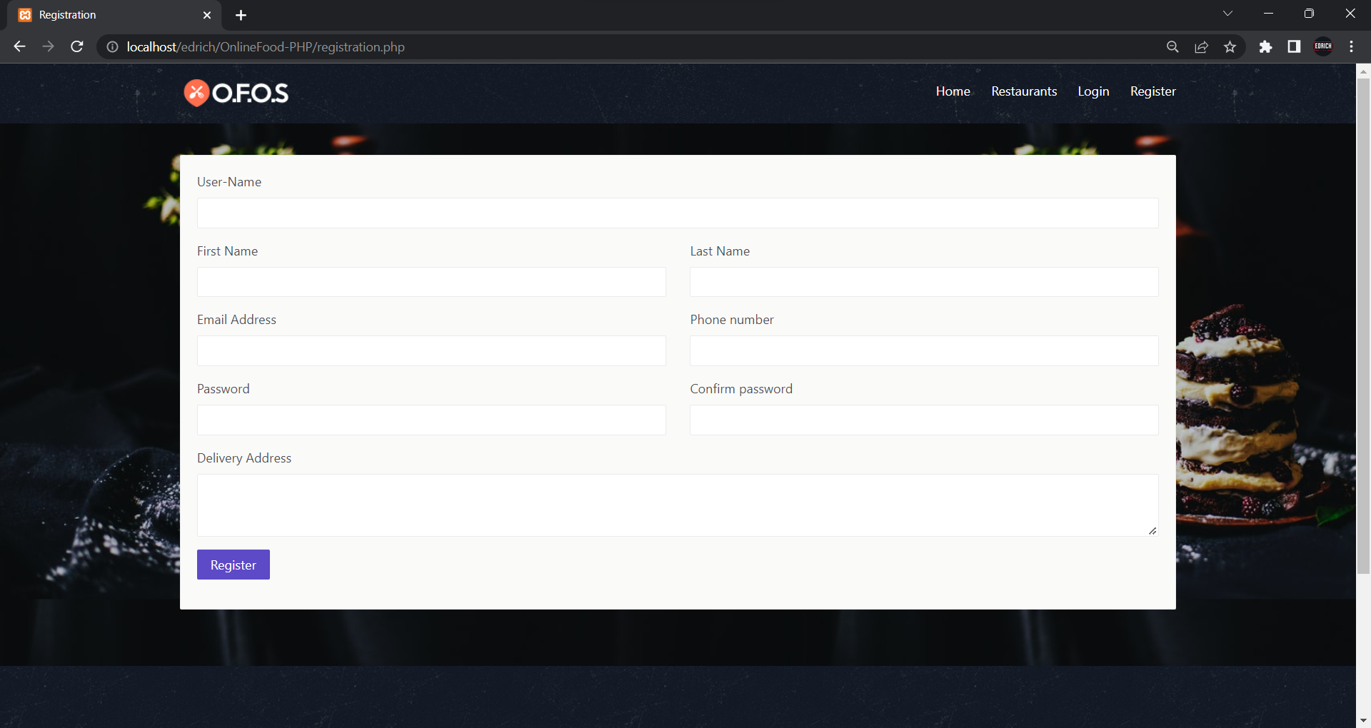

<!DOCTYPE html>

<html lang="en">

<?php

session_start();

error_reporting(0);

include("connection/connect.php");

if(isset($_POST['submit'] )) {

if(empty($_POST['firstname']) ||empty($_POST['lastname'])|| empty($_POST['email'])||empty($_POST['phone'])||empty($_POST['password'])||empty($_POST['cpassword']) ||empty($_POST['cpassword'])){

$message = "All fields must be Required!";

}

else{

$check_username= mysqli_query($db, "SELECT username FROM users where username = '".$_POST['username']."' ");

$check_email = mysqli_query($db, "SELECT email FROM users where email = '".$_POST['email']."' ");

if($_POST['password'] != $_POST['cpassword']){

echo "<script>alert('Password not match');</script>";

}

elseif(strlen($_POST['password']) < 6) {

echo "<script>alert('Password Must be >=6');</script>";

}

elseif(strlen($_POST['phone']) < 10) {

echo "<script>alert('Invalid phone number!');</script>";

}

elseif (!filter_var($_POST['email'], FILTER_VALIDATE_EMAIL)) {

echo "<script>alert('Invalid email address please type a valid email!');</script>";

}

elseif(mysqli_num_rows($check_username) > 0) {

echo "<script>alert('Username Already exists!');</script>";

}

elseif(mysqli_num_rows($check_email) > 0) {

echo "<script>alert('Email Already exists!');</script>";

}

else{$mql = "INSERT INTO users(username,f_name,l_name,email,phone,password,address) VALUES('".$_POST['username']."','".$_POST['firstname']."','".$_POST['lastname']."','".$_POST['email']."','".$_POST['phone']."','".md5($_POST['password'])."','".$_POST['address']."')";

mysqli_query($db, $mql);

header("refresh:0.1;url=login.php");

}}}?>

<head>

<meta charset="utf-8">

<meta http-equiv="X-UA-Compatible" content="IE=edge">

<meta name="viewport" content="width=device-width, initial-scale=1, shrink-to-fit=no">

<meta name="description" content="">

<meta name="author" content="">

<link rel="icon" href="#">

<title>Registration</title>

<link href="css/bootstrap.min.css" rel="stylesheet">

<link href="css/font-awesome.min.css" rel="stylesheet">

<link href="css/animsition.min.css" rel="stylesheet">

<link href="css/animate.css" rel="stylesheet">

<link href="css/style.css" rel="stylesheet"> </head>

<body>

<div style=" background-image: url('images/img/pimg.jpg');">

<header id="header" class="header-scroll top-header headrom">

<nav class="navbar navbar-dark">

<div class="container">

<button class="navbar-toggler hidden-lg-up" type="button" data-toggle="collapse" data-target="#mainNavbarCollapse">&#9776;</button>

<a class="navbar-brand" href="index.php"> <img class="img-rounded" src="images/icn.png" alt=""> </a>

<div class="collapse navbar-toggleable-md float-lg-right" id="mainNavbarCollapse">

<ul class="nav navbar-nav">

<li class="nav-item"> <a class="nav-link active" href="index.php">Home <span class="sr-only">(current)</span></a> </li>

<li class="nav-item"> <a class="nav-link active" href="restaurants.php">Restaurants <span class="sr-only"></span></a> </li>

<?php

if(empty($_SESSION["user_id"])){

echo '<li class="nav-item"><a href="login.php" class="nav-link active">Login</a> </li>

<li class="nav-item"><a href="registration.php" class="nav-link active">Register</a> </li>';

}

Else{echo '<li class="nav-item"><a href="your_orders.php" class="nav-link active">My Orders</a> </li>';

echo '<li class="nav-item"><a href="logout.php" class="nav-link active">Logout</a> </li>';}?> </ul>

</div> </div> </nav> </header>

<div class="page-wrapper">

<div class="container">

<ul>

</ul>

</div>

<section class="contact-page inner-page">

<div class="container "> <div class="row ">

<div class="col-md-12"><div class="widget" >

<div class="widget-body">

<form action="" method="post">

<div class="row">

<div class="form-group col-sm-12">

<label for="exampleInputEmail1">User-Name</label>

<input class="form-control" type="text" name="username" id="example-text-input">

</div>

<div class="form-group col-sm-6">

<label for="exampleInputEmail1">First Name</label>

<input class="form-control" type="text" name="firstname" id="example-text-input">

</div>

<div class="form-group col-sm-6">

<label for="exampleInputEmail1">Last Name</label>

<input class="form-control" type="text" name="lastname" id="example-text-input-2">

</div>

<div class="form-group col-sm-6">

<label for="exampleInputEmail1">Email Address</label>

<input type="text" class="form-control" name="email" id="exampleInputEmail1" aria-describedby="emailHelp">

</div>

<div class="form-group col-sm-6">

<label for="exampleInputEmail1">Phone number</label>

<input class="form-control" type="text" name="phone" id="example-tel-input-3">

</div>

<div class="form-group col-sm-6">

<label for="exampleInputPassword1">Password</label>

<input type="password" class="form-control" name="password" id="exampleInputPassword1">

</div>

<div class="form-group col-sm-6">

<label for="exampleInputPassword1">Confirm password</label>

<input type="password" class="form-control" name="cpassword" id="exampleInputPassword2">

</div>

<div class="form-group col-sm-12">

<label for="exampleTextarea">Delivery Address</label>

<textarea class="form-control" id="exampleTextarea" name="address" rows="3"></textarea>

</div> </div>

<div class="row"><div class="col-sm-4">

<p> <input type="submit" value="Register" name="submit" class="btn theme-btn"> </p>

</div>

</div>

</form> </div> </div> </div> </div></div> </section>

<footer class="footer">

<div class="container"><div class="row bottom-footer">

<div class="container">

<div class="row">

<div class="col-xs-12 col-sm-3 payment-options color-gray">

<h5>Payment Options</h5>

<ul>

<li>

<a href="#"> <img src="images/paypal.png" alt="Paypal"> </a>

</li>

<li>

<a href="#"> <img src="images/mastercard.png" alt="Mastercard"> </a>

</li>

<li>

<a href="#"> <img src="images/maestro.png" alt="Maestro"> </a>

</li>

<li>

<a href="#"> <img src="images/stripe.png" alt="Stripe"> </a>

</li>

<li>

<a href="#"> <img src="images/bitcoin.png" alt="Bitcoin"> </a>

</li>

</ul>

</div>

<div class="col-xs-12 col-sm-4 address color-gray">

<h5>NAME</h5>

<p>Edrich Ryan Cardozo </p>

<h5>Roll number: 20CE21</a></h5> </div>

<div class="col-xs-12 col-sm-5 additional-info color-gray">

<h5>Addition informations</h5>

<p>Online Food Ordering DBMS project by 20CE21.</p>

</div>

</div> </div> </div> </div> </footer> </div>

<script src="js/jquery.min.js"></script>

<script src="js/tether.min.js"></script>

<script src="js/bootstrap.min.js"></script>

<script src="js/animsition.min.js"></script>

<script src="js/bootstrap-slider.min.js"></script>

<script src="js/jquery.isotope.min.js"></script>

<script src="js/headroom.js"></script>

<script src="js/foodpicky.min.js"></script>

</body>

</html>

**ADMIN PANEL :**

**DASHBOARD.PHP**

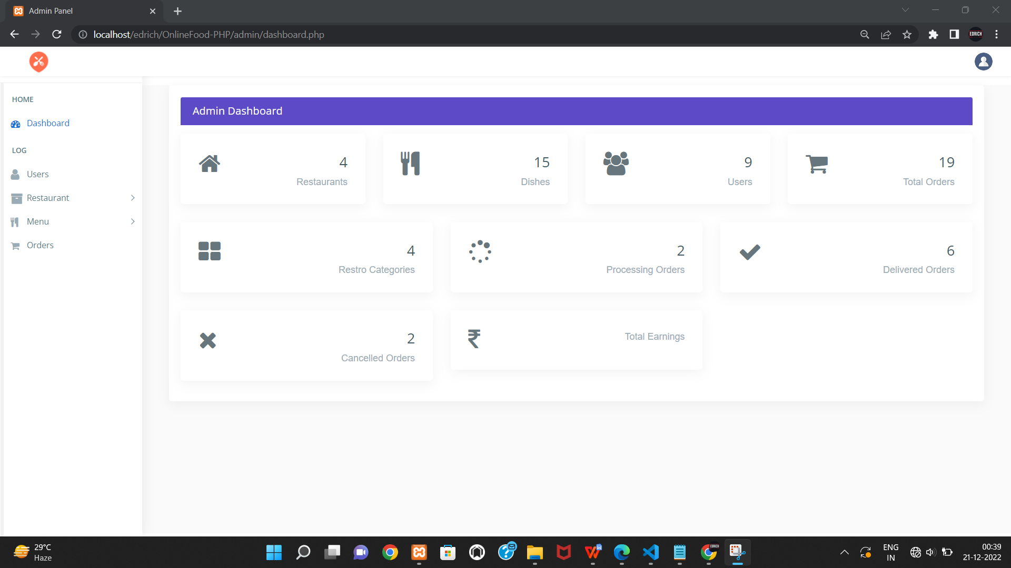

<!DOCTYPE html>

<html lang="en">

<?php

include("../connection/connect.php");

error_reporting(0);

session_start();

if(empty($_SESSION["adm_id"]))

{

header('location:index.php');

}

else

{

?>

<head>

<meta charset="utf-8">

<meta http-equiv="X-UA-Compatible" content="IE=edge">

<meta name="viewport" content="width=device-width, initial-scale=1">

<meta name="description" content="">

<meta name="author" content="">

<title>Admin Panel</title>

<link href="css/lib/bootstrap/bootstrap.min.css" rel="stylesheet">

<link href="css/helper.css" rel="stylesheet">

<link href="css/style.css" rel="stylesheet">

</head>

<body class="fix-header">

<div class="preloader">

<svg class="circular" viewBox="25 25 50 50">

<circle class="path" cx="50" cy="50" r="20" fill="none" stroke-width="2" stroke-miterlimit="10" /> </svg>

</div>

<div id="main-wrapper"><div class="header">

<nav class="navbar top-navbar navbar-expand-md navbar-light">

<div class="navbar-header">

<a class="navbar-brand" href="dashboard.php">

<span><img src="images/icn.png" alt="homepage" class="dark-logo" /></span>

</a>

</div>

<div class="navbar-collapse">

<ul class="navbar-nav mr-auto mt-md-0">

</ul>

<li class="nav-item dropdown">

<a class="nav-link dropdown-toggle text-muted " href="#" data-toggle="dropdown" aria-haspopup="true" aria-expanded="false"><img src="images/bookingSystem/user-icn.png" alt="user" class="profile-pic" /></a>

<div class="dropdown-menu dropdown-menu-right animated zoomIn">

<ul class="dropdown-user">

<li><a href="logout.php"><i class="fa fa-power-off"></i> Logout</a></li>

</ul> </div> </li></ul> </div> </nav></div>

<div class="left-sidebar"> <div class="scroll-sidebar">

<nav class="sidebar-nav">

<ul id="sidebarnav">

<li class="nav-devider"></li>

<li class="nav-label">Home</li>

<li> <a href="dashboard.php"><i class="fa fa-tachometer"></i><span>Dashboard</span></a>

</li>

<li class="nav-label">Log</li>

<li> <a href="all_users.php"> <span><i class="fa fa-user f-s-20 "></i></span><span>Users</span></a></li>

<li> <a class="has-arrow " href="#" aria-expanded="false"><i class="fa fa-archive f-s-20 color-warning"></i><span class="hide-menu">Restaurant</span></a>

<ul aria-expanded="false" class="collapse">

<li><a href="all_restaurant.php">All Restaurant</a></li>

<li><a href="add_category.php">Add Category</a></li>

<li><a href="add_restaurant.php">Add Restaurant</a></li>

</ul>

</li>

<li> <a class="has-arrow " href="#" aria-expanded="false"><i class="fa fa-cutlery" aria-hidden="true"></i><span class="hide-menu">Menu</span></a>

<ul aria-expanded="false" class="collapse">

<li><a href="all_menu.php">All Menues</a></li>

<li><a href="add_menu.php">Add Menu</a></li>

</ul> </li>

<li> <a href="all_orders.php"><i class="fa fa-shopping-cart" aria-hidden="true"></i><span>Orders</span></a></li>

</ul> </nav> </div> </div>

<div class="page-wrapper"><div class="container-fluid">

<div class="col-lg-12">

<div class="card card-outline-primary">

<div class="card-header">

<h4 class="m-b-0 text-white">Admin Dashboard</h4>

</div>

<div class="row">

<div class="col-md-3">

<div class="card p-30">

<div class="media">

<div class="media-left meida media-middle">

<span><i class="fa fa-home f-s-40 "></i></span>

</div>

<div class="media-body media-text-right">

<h2><?php $sql="select * from restaurant";

$result=mysqli_query($db,$sql);

$rws=mysqli_num_rows($result); echo $rws;?></h2>

<p class="m-b-0">Restaurants</p>

</div> </div></div> </div>

<div class="col-md-3">

<div class="card p-30"> <div class="media">

<div class="media-left meida media-middle">

<span><i class="fa fa-cutlery f-s-40" aria-hidden="true"></i></span>

</div>

<div class="media-body media-text-right">

<h2><?php $sql="select * from dishes";

$result=mysqli_query($db,$sql);

$rws=mysqli_num_rows($result);

echo $rws;?></h2>

<p class="m-b-0">Dishes</p>

</div> </div> </div> </div>

<div class="col-md-3"> <div class="card p-30">

<div class="media">

<div class="media-left meida media-middle">

<span><i class="fa fa-users f-s-40"></i></span>

</div>

<div class="media-body media-text-right">

<h2><?php $sql="select * from users";

$result=mysqli_query($db,$sql);

$rws=mysqli_num_rows($result); echo $rws;?></h2>

<p class="m-b-0">Users</p>

</div> </div> </div> </div>

<div class="col-md-3"><div class="card p-30">

<div class="media">

<div class="media-left meida media-middle">

<span><i class="fa fa-shopping-cart f-s-40" aria-hidden="true"></i></span>

</div>

<div class="media-body media-text-right">

<h2><?php $sql="select * from users_orders";

$result=mysqli_query($db,$sql);

$rws=mysqli_num_rows($result);

echo $rws;?></h2>

<p class="m-b-0">Total Orders</p>

</div> </div> </div> </div> </div>

<div class="row">

<div class="col-md-4">

<div class="card p-30">

<div class="media">

<div class="media-left meida media-middle">

<span><i class="fa fa-th-large f-s-40" aria-hidden="true"></i></span>

</div>

<div class="media-body media-text-right">

<h2><?php $sql="select * from res_category";

$result=mysqli_query($db,$sql);

$rws=mysqli_num_rows($result);

echo $rws;?></h2>

<p class="m-b-0">Restro Categories</p>

</div> </div> </div></div>

<div class="col-md-4">

<div class="card p-30">

<div class="media">

<div class="media-left meida media-middle">

<span><i class="fa fa-spinner f-s-40" aria-hidden="true"></i></span>

</div>

<div class="media-body media-text-right">

<h2><?php $sql="select * from users_orders WHERE status = 'in process' ";

$result=mysqli_query($db,$sql);

$rws=mysqli_num_rows($result);

echo $rws;?></h2>

<p class="m-b-0">Processing Orders</p>

</div> </div> </div> </div>

<div class="col-md-4"> <div class="card p-30">

<div class="media">

<div class="media-left meida media-middle">

<span><i class="fa fa-check f-s-40" aria-hidden="true"></i></span>

</div>

<div class="media-body media-text-right">

<h2><?php $sql="select * from users_orders WHERE status = 'closed' "; $result=mysqli_query($db,$sql); $rws=mysqli_num_rows($result);

echo $rws;?></h2>

<p class="m-b-0">Delivered Orders</p>

</div></div></div> </div></div>

<div class="row">

<div class="col-md-4">

<div class="card p-30">

<div class="media">

<div class="media-left meida media-middle">

<span><i class="fa fa-times f-s-40" aria-hidden="true"></i></span>

</div>

<div class="media-body media-text-right">

<h2><?php $sql="select * from users_orders WHERE status = 'rejected' ";

$result=mysqli_query($db,$sql);

$rws=mysqli_num_rows($result);

echo $rws;?></h2>

<p class="m-b-0">Cancelled Orders</p>

</div> </div></div> </div>

<div class="col-md-4">

<div class="card p-30">

<div class="media">

<div class="media-left meida media-middle">

<span><i class="fa fa-inr f-s-40" aria-hidden="true"></i></span>

</div>

<div class="media-body media-text-right">

<h2><?php

$result = mysqli_query($db, 'SELECT SUM(price) AS value_sum FROM users_orders WHERE status = "delivered"');

$row = mysqli_fetch_assoc($result);

$sum = $row['value_sum'];

echo $sum;

?></h2>

<p class="m-b-0">Total Earnings</p>

</div> </div> </div> </div> </div> </div> </div> </div>

<script src="js/lib/jquery/jquery.min.js"></script>

<script src="js/lib/bootstrap/js/popper.min.js"></script>

<script src="js/lib/bootstrap/js/bootstrap.min.js"></script>

<script src="js/jquery.slimscroll.js"></script>

</body>

</html>

<?php } ?>

**All users :**

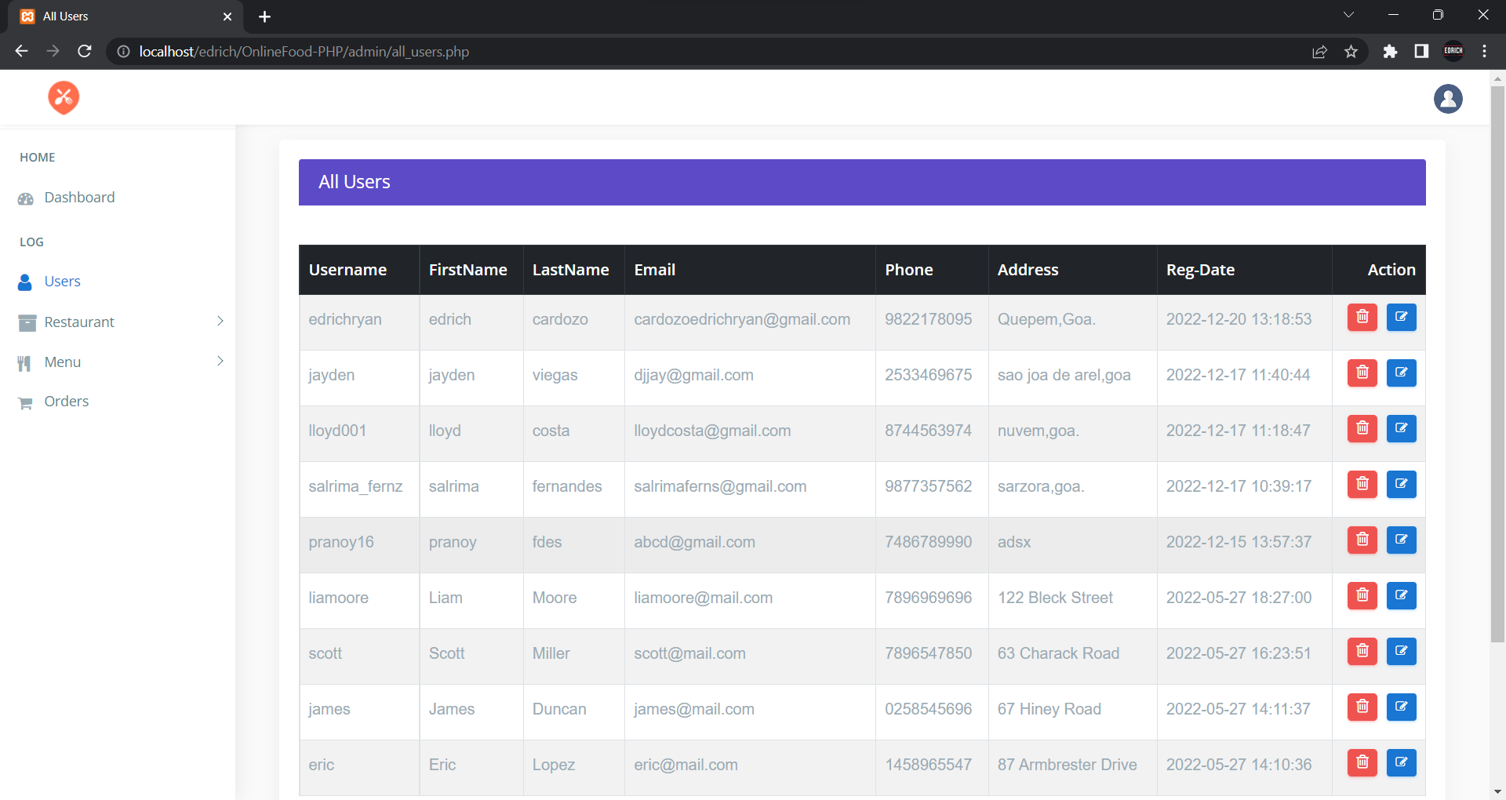

<!DOCTYPE html>

<html lang="en">

<?php

include("../connection/connect.php");

error_reporting(0);

session_start();

?>

<head>

<meta charset="utf-8">

<meta http-equiv="X-UA-Compatible" content="IE=edge">

<meta name="viewport" content="width=device-width, initial-scale=1">

<meta name="description" content="">

<meta name="author" content="">

<title>All Users</title>

<link href="css/lib/bootstrap/bootstrap.min.css" rel="stylesheet">

<link href="css/helper.css" rel="stylesheet">

<link href="css/style.css" rel="stylesheet">

</head>

<body class="fix-header fix-sidebar">

<div class="preloader">

<svg class="circular" viewBox="25 25 50 50">

<circle class="path" cx="50" cy="50" r="20" fill="none" stroke-width="2" stroke-miterlimit="10" /> </svg>

</div>

<div id="main-wrapper">

<div class="header">

<nav class="navbar top-navbar navbar-expand-md navbar-light">

<div class="navbar-header">

<a class="navbar-brand" href="dashboard.php">

<span><img src="images/icn.png" alt="homepage" class="dark-logo" /></span>

</a>

</div>

<div class="navbar-collapse">

<ul class="navbar-nav mr-auto mt-md-0">

</ul>

<ul class="navbar-nav my-lg-0">

<li class="nav-item dropdown">

<div class="dropdown-menu dropdown-menu-right mailbox animated zoomIn">

<ul>

<li>

<div class="drop-title">Notifications</div>

</li>

<li>

<a class="nav-link text-center" href="javascript:void(0);"> <strong>Check all notifications</strong> <i class="fa fa-angle-right"></i> </a>

</li> </ul> </div> </li>

<li class="nav-item dropdown">

<a class="nav-link dropdown-toggle text-muted " href="#" data-toggle="dropdown" aria-haspopup="true" aria-expanded="false"><img src="images/bookingSystem/user-icn.png" alt="user" class="profile-pic" /></a>

<div class="dropdown-menu dropdown-menu-right animated zoomIn">

<ul class="dropdown-user">

<li><a href="logout.php"><i class="fa fa-power-off"></i> Logout</a></li>

</ul> </div> </li> </ul> </div> </nav> </div>

<div class="left-sidebar">

<div class="scroll-sidebar">

<nav class="sidebar-nav">

<ul id="sidebarnav">

<li class="nav-devider"></li>

<li class="nav-label">Home</li>

<li> <a href="dashboard.php"><i class="fa fa-tachometer"></i><span>Dashboard</span></a></li>

<li class="nav-label">Log</li>

<li> <a href="all_users.php"> <span><i class="fa fa-user f-s-20 "></i></span><span>Users</span></a></li>

<li> <a class="has-arrow " href="#" aria-expanded="false"><i class="fa fa-archive f-s-20 color-warning"></i><span class="hide-menu">Restaurant</span></a>

<ul aria-expanded="false" class="collapse">

<li><a href="all_restaurant.php">All Restaurants</a></li>

<li><a href="add_category.php">Add Category</a></li>

<li><a href="add_restaurant.php">Add Restaurant</a></li>

</ul> </li> <li> <a class="has-arrow " href="#" aria-expanded="false"><i class="fa fa-cutlery" aria-hidden="true"></i><span class="hide-menu">Menu</span></a>

<ul aria-expanded="false" class="collapse">

<li><a href="all_menu.php">All Menues</a></li>

<li><a href="add_menu.php">Add Menu</a></li>

</ul> </li>

<li> <a href="all_orders.php"><i class="fa fa-shopping-cart" aria-hidden="true"></i><span>Orders</span></a></li>

</ul> </nav></div> </div>

<div class="page-wrapper">

<div class="container-fluid">

<div class="row"> <div class="col-12">

<div class="col-lg-12"> <div class="card card-outline-primary">

<div class="card-header">

<h4 class="m-b-0 text-white">All Users</h4>

</div>

<div class="table-responsive m-t-40">

<table id="myTable" class="table table-bordered table-striped table-hover">

<thead class="thead-dark">

<tr>

<th>Username</th>

<th>FirstName</th>

<th>LastName</th>

<th>Email</th>

<th>Phone</th>

<th>Address</th>

<th>Reg-Date</th> <th>Action</th> </tr> </thead> <tbody>

<?php $sql="SELECT * FROM users order by u_id desc"; $query=mysqli_query($db,$sql);

if(!mysqli_num_rows($query) > 0 ){echo '<td colspan="7"><center>No Users</center></td>';} else{while($rows=mysqli_fetch_array($query)){

echo ' <tr><td>'.$rows['username'].'</td>

<td>'.$rows['f_name'].'</td>

<td>'.$rows['l_name'].'</td>

<td>'.$rows['email'].'</td>

<td>'.$rows['phone'].'</td>

<td>'.$rows['address'].'</td> <td>'.$rows['date'].'</td>

<td><a href="delete_users.php?user_del='.$rows['u_id'].'" class="btn btn-danger btn-flat btn-addon btn-xs m-b-10"><i class="fa fa-trash-o" style="font-size:16px"></i></a>

<a href="update_users.php?user_upd='.$rows['u_id'].'" " class="btn btn-info btn-flat btn-addon btn-sm m-b-10 m-l-5"><i class="fa fa-edit"></i></a>

</td></tr>';}}?>

</tbody>

</table> </div> </div> </div></div> </div> </div> </div> </div></div>

<footer class="footer">Online Food Ordering System by Edrich Ryan Cardozo </footer>

</div> </div>

<script src="js/lib/jquery/jquery.min.js"></script>>

<script src="js/lib/bootstrap/js/popper.min.js"></script>

<script src="js/lib/bootstrap/js/bootstrap.min.js"></script>

</body>

</html>

**Update user.php**

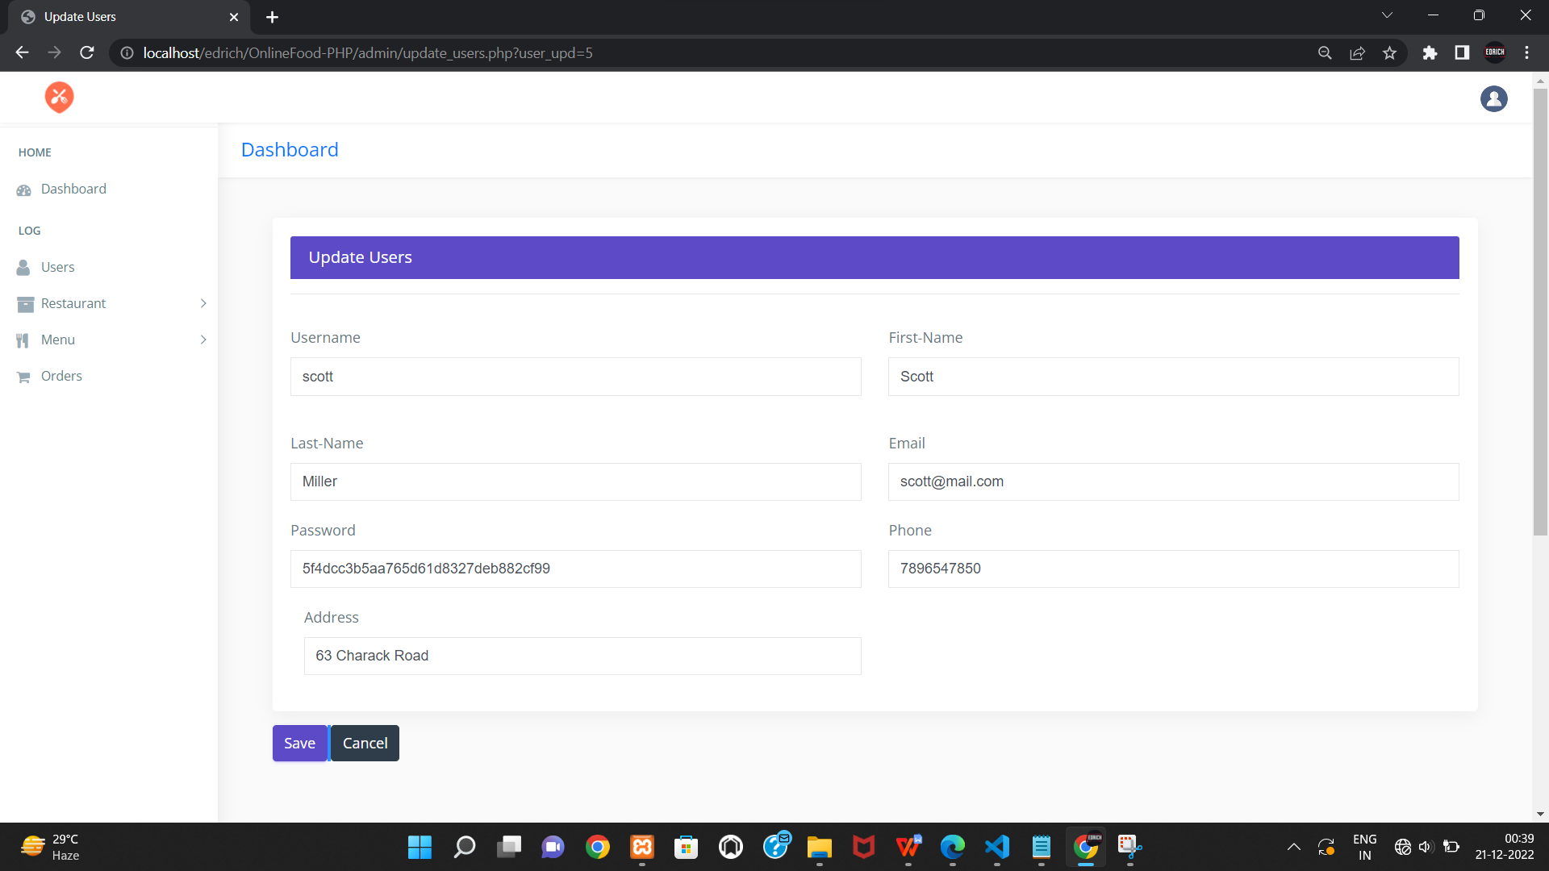

<!DOCTYPE html>

<html lang="en">

<?php

session_start();

error_reporting(0);

include("../connection/connect.php");

if(isset($_POST['submit'] )){

if(empty($_POST['uname']) || empty($_POST['fname'])|| empty($_POST['lname']||empty($_POST['email'])||empty($_POST['password'])||empty($_POST['phone'])){

$error = '<div class="alert alert-danger alert-dismissible fade show">

<button type="button" class="close" data-dismiss="alert" aria-label="Close"><span aria-hidden="true">&times;</span></button>

<strong>All fields Required!</strong></div>';}

else{

if(!filter_var($_POST['email'], FILTER_VALIDATE_EMAIL)) // Validate email address {

$error = '<div class="alert alert-danger alert-dismissible fade show">

<button type="button" class="close" data-dismiss="alert" aria-label="Close"><span aria-hidden="true">&times;</span></button>

<strong>invalid email!</strong></div>'; }

elseif(strlen($_POST['password']) < 6){

$error = '<div class="alert alert-danger alert-dismissible fade show">

<button type="button" class="close" data-dismiss="alert" aria-label="Close"><span aria-hidden="true">&times;</span></button>

<strong>Password must be >=6!</strong></div>';}

elseif(strlen($_POST['phone']) < 10){

$error = '<div class="alert alert-danger alert-dismissible fade show">

<button type="button" class="close" data-dismiss="alert" aria-label="Close"><span aria-hidden="true">&times;</span></button>

<strong>invalid phone!</strong></div>';}

else{

$mql = "update users set username='$_POST[uname]', f_name='$_POST[fname]', l_name='$_POST[lname]',email='$_POST[email]',phone='$_POST[phone]',password='".md5($_POST['password'])."',address='$_POST[address]' where u_id='$_GET[user_upd]' ";

mysqli_query($db, $mql);

$success ='<div class="alert alert-success alert-dismissible fade show">

<button type="button" class="close" data-dismiss="alert" aria-label="Close"><span aria-hidden="true">&times;</span></button>

<strong>User Updated!</strong></div>';

}}}

?>

<head>

<meta charset="utf-8">

<meta http-equiv="X-UA-Compatible" content="IE=edge">

<meta name="viewport" content="width=device-width, initial-scale=1">

<meta name="description" content="">

<meta name="author" content="">

<link rel="icon" type="image/png" sizes="16x16" href="images/favicon.png">

<title>Update Users</title>

<link href="css/lib/bootstrap/bootstrap.min.css" rel="stylesheet">

<link href="css/helper.css" rel="stylesheet">

<link href="css/style.css" rel="stylesheet">

</head>

<body class="fix-header">

<div class="preloader">

<svg class="circular" viewBox="25 25 50 50">

<circle class="path" cx="50" cy="50" r="20" fill="none" stroke-width="2" stroke-miterlimit="10" /> </svg>

</div>

<div id="main-wrapper">

<div class="header">

<nav class="navbar top-navbar navbar-expand-md navbar-light">

<div class="navbar-header">

<a class="navbar-brand" href="dashboard.php">

<span><img src="images/icn.png" alt="homepage" class="dark-logo" /></span>

</a> </div>

<div class="navbar-collapse">

<ul class="navbar-nav mr-auto mt-md-0">

</ul>

<ul class="navbar-nav my-lg-0">

<li class="nav-item dropdown">

<div class="dropdown-menu dropdown-menu-right mailbox animated zoomIn">

<ul> <li>

<div class="drop-title">Notifications</div>

</li><li>

<a class="nav-link text-center" href="javascript:void(0);"> <strong>Check all notifications</strong> <i class="fa fa-angle-right"></i> </a>

</li> </ul> </div> </li>

<li class="nav-item dropdown">

<a class="nav-link dropdown-toggle text-muted " href="#" data-toggle="dropdown" aria-haspopup="true" aria-expanded="false"><img src="images/bookingSystem/user-icn.png" alt="user" class="profile-pic" /></a>

<div class="dropdown-menu dropdown-menu-right animated zoomIn">

<ul class="dropdown-user">

<li><a href="logout.php"><i class="fa fa-power-off"></i> Logout</a></li>

</ul> </div> </li> </ul> </div> </nav> </div>

<div class="left-sidebar">

<div class="scroll-sidebar">

<nav class="sidebar-nav">

<ul id="sidebarnav">

<li class="nav-devider"></li>

<li class="nav-label">Home</li>

<li> <a href="dashboard.php"><i class="fa fa-tachometer"></i><span>Dashboard</span></a></li>

<li class="nav-label">Log</li>

<li> <a href="all_users.php"> <span><i class="fa fa-user f-s-20 "></i></span><span>Users</span></a></li>

<li> <a class="has-arrow " href="#" aria-expanded="false"><i class="fa fa-archive f-s-20 color-warning"></i><span class="hide-menu">Restaurant</span></a>

<ul aria-expanded="false" class="collapse">

<li><a href="all_restaurant.php">All Restaurants</a></li>

<li><a href="add_category.php">Add Category</a></li>

<li><a href="add_restaurant.php">Add Restaurant</a></li>

</ul> </li>

<li> <a class="has-arrow " href="#" aria-expanded="false"><i class="fa fa-cutlery" aria-hidden="true"></i><span class="hide-menu">Menu</span></a>

<ul aria-expanded="false" class="collapse">

<li><a href="all_menu.php">All Menues</a></li>

<li><a href="add_menu.php">Add Menu</a></li></ul>

</li>

<li> <a href="all_orders.php"><i class="fa fa-shopping-cart" aria-hidden="true"></i><span>Orders</span></a></li> </ul> </nav> </div> </div>

<div class="page-wrapper" style="height:1200px;">

<div class="row page-titles">

<div class="col-md-5 align-self-center">

<h3 class="text-primary">Dashboard</h3> </div></div>

<div class="container-fluid"> <div class="row"> <div class="container-fluid">

<?php

echo $error;

echo $success; ?>

<div class="col-lg-12">

<div class="card card-outline-primary">

<div class="card-header">

<h4 class="m-b-0 text-white">Update Users</h4>

</div>

<div class="card-body">

<?php $ssql ="select * from users where u_id='$_GET[user_upd]'"; $res=mysqli_query($db, $ssql); $newrow=mysqli_fetch_array($res);?>

<form action='' method='post' >

<div class="form-body">

<hr><div class="row p-t-20">

<div class="col-md-6">

<div class="form-group">

<label class="control-label">Username</label>

<input type="text" name="uname" class="form-control" value="<?php echo $newrow['username']; ?>" placeholder="username">

</div> </div>

<div class="col-md-6">

<div class="form-group has-danger">

<label class="control-label">First-Name</label>

<input type="text" name="fname" class="form-control form-control-danger" value="<?php echo $newrow['f_name']; ?>" placeholder="jon">

</div> </div> </div>

<div class="row p-t-20">

<div class="col-md-6">

<div class="form-group">

<label class="control-label">Last-Name </label>

<input type="text" name="lname" class="form-control" placeholder="doe" value="<?php echo $newrow['l_name']; ?>">

</div> </div>

<div class="col-md-6">

<div class="form-group has-danger">

<label class="control-label">Email</label>

<input type="text" name="email" class="form-control form-control-danger" value="<?php echo $newrow['email']; ?>" placeholder="example@gmail.com">

</div> </div> </div>

<div class="row">

<div class="col-md-6">

<div class="form-group">

<label class="control-label">Password</label>

<input type="text" name="password" class="form-control form-control-danger" value="<?php echo $newrow['password']; ?>" placeholder="password">

</div> </div>

<div class="col-md-6">

<div class="form-group">

<label class="control-label">Phone</label>

<input type="text" name="phone" class="form-control form-control-danger" value="<?php echo $newrow['phone']; ?>" placeholder="phone">

</div> </div> </div>

<div class="col-md-6">

<div class="form-group">

<label class="control-label">Address</label>

<input type="text" name="address" class="form-control form-control-danger" value="<?php echo $newrow['address']; ?>" placeholder="Address">

</div> </div> </div></div> </div>

<div class="form-actions">

<input type="submit" name="submit" class="btn btn-primary" value="Save">

<a href="all_users.php" class="btn btn-inverse">Cancel</a>

</div>

</form></div> </div> </div> </div> </div>

<footer class="footer">Online Food Ordering System by Edrich Ryan Cardozo </footer>

</div></div>

<script src="js/lib/jquery/jquery.min.js"></script>

<script src="js/lib/bootstrap/js/popper.min.js"></script>

<script src="js/lib/bootstrap/js/bootstrap.min.js"></script>

<script src="js/jquery.slimscroll.js"></script>

</body>

</html>

**Del_user:**

<?php

include("../connection/connect.php");

error_reporting(0);

session_start();

mysqli_query($db,"DELETE FROM users WHERE u_id = '".$_GET['user_del']."'");

header("location:all_users.php");

?>

**ALL_MENU.PHP**

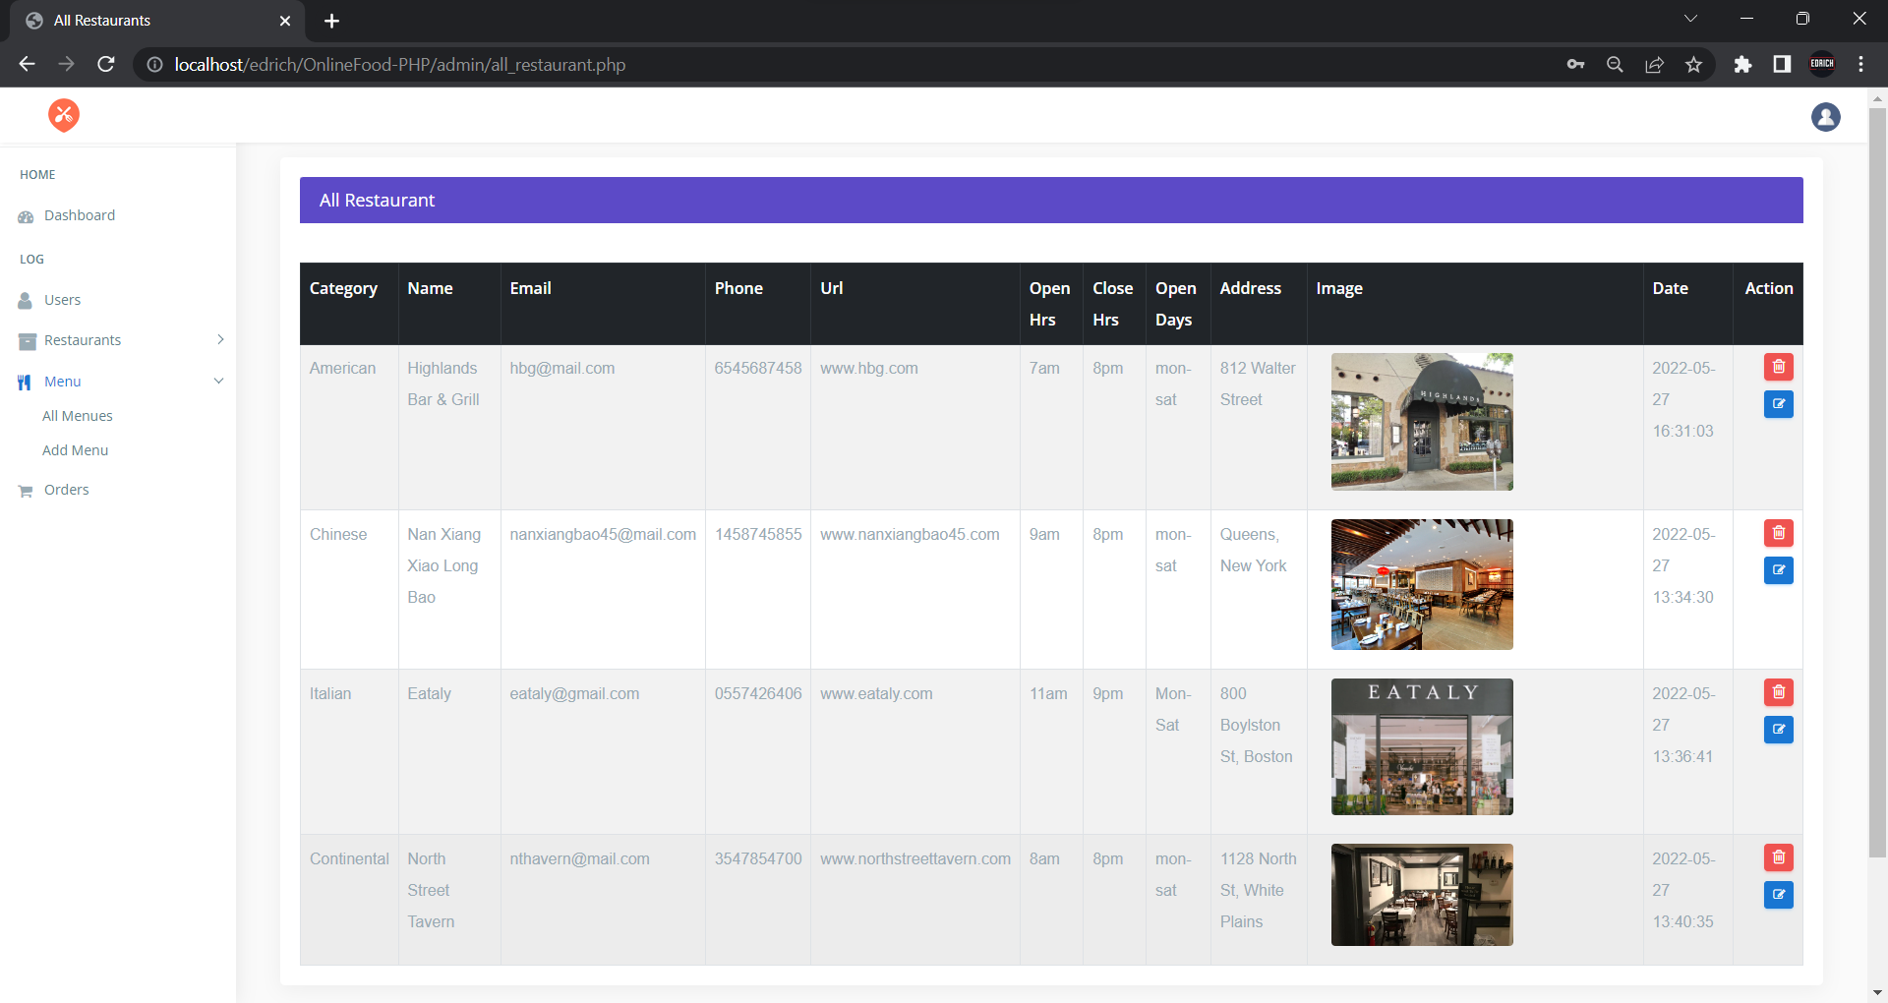

<!DOCTYPE html>

<html lang="en">

<?php

include("../connection/connect.php");

error_reporting(0);

session_start();

?>

<head>

<meta charset="utf-8">

<meta http-equiv="X-UA-Compatible" content="IE=edge">

<meta name="viewport" content="width=device-width, initial-scale=1">

<meta name="description" content="">

<meta name="author" content="">

<link rel="icon" type="image/png" sizes="16x16" href="images/favicon.png">

<title>All Menu</title>

<link href="css/lib/bootstrap/bootstrap.min.css" rel="stylesheet">

<link href="css/helper.css" rel="stylesheet">

<link href="css/style.css" rel="stylesheet">

</head>

<body class="fix-header fix-sidebar"> <div class="preloader">

<svg class="circular" viewBox="25 25 50 50">

<circle class="path" cx="50" cy="50" r="20" fill="none" stroke-width="2" stroke-miterlimit="10" /> </svg> </div>

<div id="main-wrapper"> <div class="header">

<nav class="navbar top-navbar navbar-expand-md navbar-light">

<div class="navbar-header">

<a class="navbar-brand" href="dashboard.php">

<span><img src="images/icn.png" alt="homepage" class="dark-logo" /></span>

</a> </div>

<div class="navbar-collapse">

<ul class="navbar-nav mr-auto mt-md-0">

</ul>

<ul class="navbar-nav my-lg-0">

<li class="nav-item dropdown">

<div class="dropdown-menu dropdown-menu-right mailbox animated zoomIn">

<ul> <li>

<div class="drop-title">Notifications</div>

</li> <li>

<a class="nav-link text-center" href="javascript:void(0);"> <strong>Check all notifications</strong> <i class="fa fa-angle-right"></i> </a>

</li> </ul> </div>

</li>

<li class="nav-item dropdown">

<a class="nav-link dropdown-toggle text-muted " href="#" data-toggle="dropdown" aria-haspopup="true" aria-expanded="false"><img src="images/bookingSystem/user-icn.png" alt="user" class="profile-pic" /></a>

<div class="dropdown-menu dropdown-menu-right animated zoomIn">

<ul class="dropdown-user">

<li><a href="logout.php"><i class="fa fa-power-off"></i> Logout</a></li>

</ul> </div> </li> </ul>

</div>

</nav> </div>

<div class="left-sidebar"> <div class="scroll-sidebar"> <nav class="sidebar-nav">

<ul id="sidebarnav">

<li class="nav-devider"></li>

<li class="nav-label">Home</li>

<li> <a href="dashboard.php"><i class="fa fa-tachometer"></i><span>Dashboard</span></a></li>

<li class="nav-label">Log</li>

<li> <a href="all_users.php"> <span><i class="fa fa-user f-s-20 "></i></span><span>Users</span></a></li>

<li> <a class="has-arrow " href="#" aria-expanded="false"><i class="fa fa-archive f-s-20 color-warning"></i><span class="hide-menu">Restaurant</span></a>

<ul aria-expanded="false" class="collapse">

<li><a href="all_restaurant.php">All Restaurants</a></li>

<li><a href="add_category.php">Add Category</a></li>

<li><a href="add_restaurant.php">Add Restaurant</a></li>

</ul>

</li>

<li> <a class="has-arrow " href="#" aria-expanded="false"><i class="fa fa-cutlery" aria-hidden="true"></i><span class="hide-menu">Menu</span></a>

<ul aria-expanded="false" class="collapse">

<li><a href="all_menu.php">All Menues</a></li>

<li><a href="add_menu.php">Add Menu</a></li>

</ul>

</li>

<li> <a href="all_orders.php"><i class="fa fa-shopping-cart" aria-hidden="true"></i><span>Orders</span></a></li>

</ul></nav></div> </div>

<div class="page-wrapper"> <div class="container-fluid"> <div class="row">

<div class="col-12">

<div class="col-lg-12"> <div class="card card-outline-primary">

<div class="card-header">

<h4 class="m-b-0 text-white">All Menu</h4>

</div>

<div class="table-responsive m-t-40">

<table id="example23" class="display nowrap table table-hover table-striped table-bordered" cellspacing="0" width="100%">

<thead class="thead-dark">

<tr><th>Restaurant</th>

<th>Dish</th>

<th>Description</th>

<th>Price</th>

<th>Image</th>

<th>Action</th>

</tr>

</thead> <tbody>

<?php $sql="SELECT * FROM dishes order by d_id desc"; $query=mysqli_query($db,$sql);

if(!mysqli_num_rows($query) > 0 ){

echo '<td colspan="11"><center>No Menu</center></td>';}

else{

while($rows=mysqli_fetch_array($query)){

$mql="select * from restaurant where rs_id='".$rows['rs_id']."'";

$newquery=mysqli_query($db,$mql);

echo '<tr><td>'.$fetch['title'].'</td>

<td>'.$rows['title'].'</td>

<td>'.$rows['slogan'].'</td>

<td>Rs'.$rows['price'].'</td>

<td><div class="col-md-3 col-lg-8 m-b-10">

<center><img src="Res_img/dishes/'.$rows['img'].'" class="img-responsive radius" style="max-height:100px;max-width:150px;" /></center>

</div></td><td><a href="delete_menu.php?menu_del='.$rows['d_id'].'" class="btn btn-danger btn-flat btn-addon btn-xs m-b-10"><i class="fa fa-trash-o" style="font-size:16px"></i></a>

<a href="update_menu.php?menu_upd='.$rows['d_id'].'" class="btn btn-info btn-flat btn-addon btn-sm m-b-10 m-l-5"><i class="fa fa-edit"></i></a>

</td></tr>'}}?>

</tbody>

</table> </div></div> </div></div> </div></div> </div>

</div>

</div><footer class="footer">Online Food Ordering System by Edrich Ryan Cardozo</footer>

</div></div>

<script src="js/lib/jquery/jquery.min.js"></script>

<script src="js/lib/bootstrap/js/popper.min.js"></script>

<script src="js/lib/bootstrap/js/bootstrap.min.js"></script>

<script src="js/jquery.slimscroll.js"></script>

<script >src="js/lib/datatables/cdn.datatables.net/buttons/1.2.2/js/dataTables.buttons.min.js"></script>

<script src="js/lib/datatables/cdn.datatables.net/buttons/1.2.2/js/buttons.flash.min.js"></script>

<script src="js/lib/datatables/cdnjs.cloudflare.com/ajax/libs/jszip/2.5.0/jszip.min.js"></script>

</body>

</html>

**ADD_MENU.PHP**

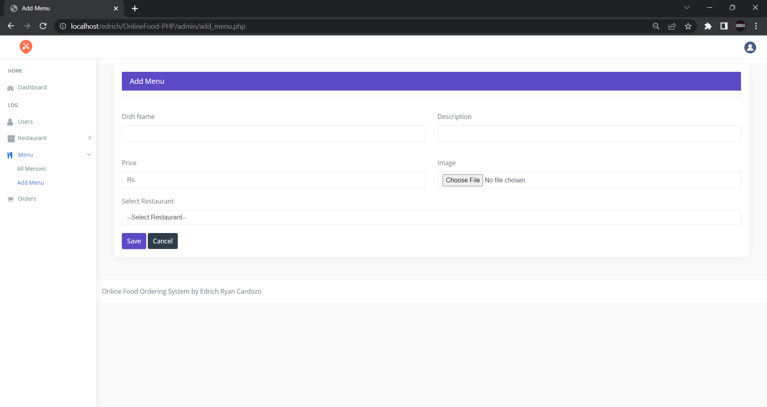

<!DOCTYPE html>

<html lang="en">

<?php

include("../connection/connect.php");

error_reporting(0);

session_start();

if(isset($_POST['submit'])) {

if(empty($_POST['d_name'])||empty($_POST['about'])||$_POST['price']==''||$_POST['res_name']==''){

$error ='<div class="alert alert-danger alert-dismissible fade show">

<button type="button" class="close" data-dismiss="alert" aria-label="Close"><span aria-hidden="true">&times;</span></button>

<strong>All fields Must be Fillup!</strong></div>';

}

else{

$fname = $_FILES['file']['name'];

$temp = $_FILES['file']['tmp_name'];

$fsize = $_FILES['file']['size'];

$extension = explode('.',$fname);

$extension = strtolower(end($extension));

$fnew = uniqid().'.'.$extension;

$store = "Res_img/dishes/".basename($fnew);

if($extension == 'jpg'||$extension == 'png'||$extension == 'gif' ){

if($fsize>=1000000){

$error = '<div class="alert alert-danger alert-dismissible fade show">

<button type="button" class="close" data-dismiss="alert" aria-label="Close"><span aria-hidden="true">&times;</span></button>

<strong>Max Image Size is 1024kb!</strong> Try different Image.

</div>';

else{

$sql = "INSERT INTO dishes(rs_id,title,slogan,price,img) VALUE('".$_POST['res_name']."','".$_POST['d_name']."','".$_POST['about']."','".$_POST['price']."','".$fnew."')"; // store the submited data ino the database :images

mysqli_query($db, $sql);

move_uploaded_file($temp, $store);

$success = '<div class="alert alert-success alert-dismissible fade show">

<button type="button" class="close" data-dismiss="alert" aria-label="Close"><span aria-hidden="true">&times;</span></button>

New Dish Added Successfully.

</div>';}}

elseif($extension == ''){ $error = '<div class="alert alert-danger alert-dismissible fade show">

<button type="button" class="close" data-dismiss="alert" aria-label="Close"><span aria-hidden="true">&times;</span></button>

<strong>select image</strong>

</div>';

}

else{

$error = '<div class="alert alert-danger alert-dismissible fade show">

<button type="button" class="close" data-dismiss="alert" aria-label="Close"><span aria-hidden="true">&times;</span></button>

<strong>invalid extension!</strong>png, jpg, Gif are accepted.

</div>';} }}?>

<head>

<meta charset="utf-8">

<meta http-equiv="X-UA-Compatible" content="IE=edge">

<meta name="viewport" content="width=device-width, initial-scale=1">

<meta name="description" content="">

<meta name="author" content="">

<link rel="icon" type="image/png" sizes="16x16" href="images/favicon.png">

<title>Add Menu</title>

<link href="css/lib/bootstrap/bootstrap.min.css" rel="stylesheet">

<link href="css/helper.css" rel="stylesheet">

<link href="css/style.css" rel="stylesheet">

</head>

<body class="fix-header">

<div class="preloader">

<svg class="circular" viewBox="25 25 50 50">

<circle class="path" cx="50" cy="50" r="20" fill="none" stroke-width="2" stroke-miterlimit="10" /> </svg>

</div>

<div id="main-wrapper"> <div class="header">

<nav class="navbar top-navbar navbar-expand-md navbar-light">

<div class="navbar-header">

<a class="navbar-brand" href="dashboard.php">

<span><img src="images/icn.png" alt="homepage" class="dark-logo" /></span>

</a>

</div>

<div class="navbar-collapse">

<ul class="navbar-nav mr-auto mt-md-0">

</ul>

<ul class="navbar-nav my-lg-0">

<li class="nav-item dropdown"><div class="dropdown-menu dropdown-menu-right mailbox animated zoomIn">

<ul><li>

<div class="drop-title">Notifications</div>

</li>

<li>

<a class="nav-link text-center" href="javascript:void(0);"> <strong>Check all notifications</strong> <i class="fa fa-angle-right"></i> </a>

</li>

</ul> </div>

</li>

<li class="nav-item dropdown">

<a class="nav-link dropdown-toggle text-muted " href="#" data-toggle="dropdown" aria-haspopup="true" aria-expanded="false"><img src="images/bookingSystem/user-icn.png" alt="user" class="profile-pic" /></a>

<div class="dropdown-menu dropdown-menu-right animated zoomIn">

<ul class="dropdown-user">

<li><a href="logout.php"><i class="fa fa-power-off"></i> Logout</a></li>

</ul>

</div></li></ul></div> </nav></div>

<div class="left-sidebar"><div class="scroll-sidebar">

<nav class="sidebar-nav">

<ul id="sidebarnav">

<li class="nav-devider"></li>

<li class="nav-label">Home</li>

<li> <a href="dashboard.php"><i class="fa fa-tachometer"></i><span>Dashboard</span></a></li>

<li class="nav-label">Log</li>

<li> <a href="all_users.php"> <span><i class="fa fa-user f-s-20 "></i></span><span>Users</span></a></li>

<li> <a class="has-arrow " href="#" aria-expanded="false"><i class="fa fa-archive f-s-20 color-warning"></i><span class="hide-menu">Restaurant</span></a>

<ul aria-expanded="false" class="collapse">

<li><a href="all_restaurant.php">All Restaurants</a></li>

<li><a href="add_category.php">Add Category</a></li>

<li><a href="add_restaurant.php">Add Restaurant</a></li>

</ul>

</li>

<li> <a class="has-arrow " href="#" aria-expanded="false"><i class="fa fa-cutlery" aria-hidden="true"></i><span class="hide-menu">Menu</span></a>

<ul aria-expanded="false" class="collapse">

<li><a href="all_menu.php">All Menues</a></li>

<li><a href="add_menu.php">Add Menu</a></li>

</ul>

</li>

<li> <a href="all_orders.php"><i class="fa fa-shopping-cart" aria-hidden="true"></i><span>Orders</span></a></li>

</ul> </nav> </div></div>

<div class="page-wrapper"> <div class="container-fluid">

<!-- Start Page Content -->

<?php echo $error;

echo $success; ?>

<div class="col-lg-12"> <div class="card card-outline-primary">

<div class="card-header">

<h4 class="m-b-0 text-white">Add Menu</h4>

</div>

<div class="card-body">

<form action='' method='post' enctype="multipart/form-data">

<div class="form-body">

<hr>

<div class="row p-t-20">

<div class="col-md-6">

<div class="form-group">

<label class="control-label">Dish Name</label>

<input type="text" name="d_name" class="form-control" >

</div>

</div>

<div class="col-md-6">

<div class="form-group has-danger">

<label class="control-label">Description</label>

<input type="text" name="about" class="form-control form-control-danger" >

</div>

</div>

</div>

<div class="row p-t-20">

<div class="col-md-6">

<div class="form-group">

<label class="control-label">Price </label>

<input type="text" name="price" class="form-control" placeholder="Rs.">

</div>

</div>

<div class="col-md-6">

<div class="form-group has-danger">

<label class="control-label">Image</label>

<input type="file" name="file" id="lastName" class="form-control form-control-danger" placeholder="12n">

</div>

</div>

</div>

<div class="row"><div class="col-md-12">

<div class="form-group">

<label class="control-label">Select Restaurant</label>

<select name="res_name" class="form-control custom-select" data-placeholder="Choose a Category" tabindex="1">

<option>--Select Restaurant--</option>

<?php $ssql ="select * from restaurant";

$res=mysqli_query($db, $ssql);

while($row=mysqli_fetch_array($res)) {

echo' <option value="'.$row['rs_id'].'">'.$row['title'].'</option>';;

} ?> </select>

</div> </div> </div> </div>

</div>

<div class="form-actions">

<input type="submit" name="submit" class="btn btn-primary" value="Save">

<a href="add_menu.php" class="btn btn-inverse">Cancel</a>

</div>

</form>

</div></div> </div>

<footer class="footer">Online Food Ordering System by Edrich Ryan Cardozo </footer>

</div> </div> </div> </div>

<script src="js/lib/jquery/jquery.min.js"></script>

<script src="js/lib/bootstrap/js/popper.min.js"></script>

<script src="js/lib/bootstrap/js/bootstrap.min.js"></script>

</body>

</html>

**UPDATE_MENU.PHP**

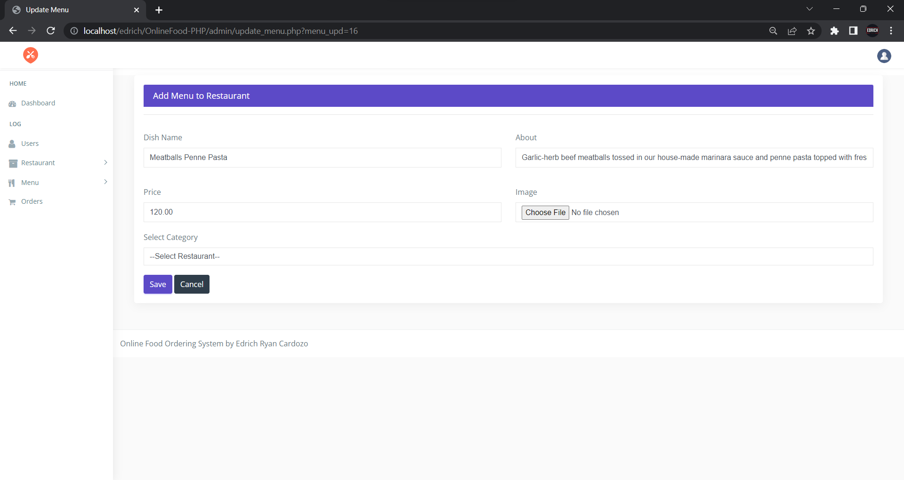

<!DOCTYPE html>

<html lang="en">

<?php

include("../connection/connect.php");

error_reporting(0);

session_start();

if(isset($_POST['submit'])) //if upload btn is pressed{

if(empty($_POST['d_name'])||empty($_POST['about'])||$_POST['price']==''||$_POST['res_name']==''){

$error = '<div class="alert alert-danger alert-dismissible fade show">

<button type="button" class="close" data-dismiss="alert" aria-label="Close"><span aria-hidden="true">&times;</span></button> <strong>All fields Must be Fillup!</strong> </div>';

}

else{

$fname = $_FILES['file']['name'];

$temp = $_FILES['file']['tmp_name'];

$fsize = $_FILES['file']['size'];

$extension = explode('.',$fname);

$extension = strtolower(end($extension));

$fnew = uniqid().'.'.$extension;

$store = "Res_img/dishes/".basename($fnew);

if($extension == 'jpg'||$extension == 'png'||$extension == 'gif' ){

if($fsize>=1000000){

$error = '<div class="alert alert-danger alert-dismissible fade show">

<button type="button" class="close" data-dismiss="alert" aria-label="Close"><span aria-hidden="true">&times;</span></button>

<strong>Max Image Size is 1024kb!</strong> Try different Image.

</div>';}

else{

$sql = "update dishes set rs_id='$_POST[res_name]',title='$_POST[d_name]',slogan='$_POST[about]',price='$_POST[price]',img='$fnew' where d_id='$_GET[menu_upd]'";

mysqli_query($db, $sql); move_uploaded_file($temp, $store);

$success ='<div class="alert alert-success alert-dismissible fade show">

<button type="button" class="close" data-dismiss="alert" aria-label="Close"><span aria-hidden="true">&times;</span></button>

<strong>Record Updated!</strong>

</div>';}} }}?>

<head>

<meta charset="utf-8">

<meta http-equiv="X-UA-Compatible" content="IE=edge">

<meta name="viewport" content="width=device-width, initial-scale=1">

<meta name="description" content="">

<meta name="author" content="">

<link rel="icon" type="image/png" sizes="16x16" href="images/favicon.png">

<title>Update Menu</title>

<link href="css/lib/bootstrap/bootstrap.min.css" rel="stylesheet">

<link href="css/helper.css" rel="stylesheet">

<link href="css/style.css" rel="stylesheet">

</head>

<body class="fix-header"> <div class="preloader">

<svg class="circular" viewBox="25 25 50 50">

<circle class="path" cx="50" cy="50" r="20" fill="none" stroke-width="2" stroke-miterlimit="10" /> </svg>

</div>

<div id="main-wrapper"> <div class="header">

<nav class="navbar top-navbar navbar-expand-md navbar-light">

<div class="navbar-header">

<a class="navbar-brand" href="dashboard.php">

<span><img src="images/icn.png" alt="homepage" class="dark-logo" /></span>

</a>

</div>

<div class="navbar-collapse">

<ul class="navbar-nav mr-auto mt-md-0">

</ul>

<ul class="navbar-nav my-lg-0">

<li class="nav-item dropdown">

<a class="nav-link dropdown-toggle text-muted " href="#" data-toggle="dropdown" aria-haspopup="true" aria-expanded="false"><img src="images/bookingSystem/user-icn.png" alt="user" class="profile-pic" /></a>

<div class="dropdown-menu dropdown-menu-right animated zoomIn">

<ul class="dropdown-user">

<li><a href="logout.php"><i class="fa fa-power-off"></i> Logout</a></li>

</ul> </div>

</li> </ul> </div> </nav>

</div>

<div class="left-sidebar"> <div class="scroll-sidebar"> <nav class="sidebar-nav">

<ul id="sidebarnav">

<li class="nav-devider"></li>

<li class="nav-label">Home</li>

<li> <a href="dashboard.php"><i class="fa fa-tachometer"></i><span>Dashboard</span></a></li>

<li class="nav-label">Log</li>

<li> <a href="all_users.php"> <span><i class="fa fa-user f-s-20 "></i></span><span>Users</span></a></li>

<li> <a class="has-arrow " href="#" aria-expanded="false"><i class="fa fa-archive f-s-20 color-warning"></i><span class="hide-menu">Restaurant</span></a>

<ul aria-expanded="false" class="collapse">

<li><a href="all_restaurant.php">All Restaurants</a></li>

<li><a href="add_category.php">Add Category</a></li>

<li><a href="add_restaurant.php">Add Restaurant</a></li>

</ul>

</li>

<li> <a class="has-arrow " href="#" aria-expanded="false"><i class="fa fa-cutlery" aria-hidden="true"></i><span class="hide-menu">Menu</span></a>

<ul aria-expanded="false" class="collapse">

<li><a href="all_menu.php">All Menues</a></li>

<li><a href="add_menu.php">Add Menu</a></li>

</ul> </li>

<li> <a href="all_orders.php"><i class="fa fa-shopping-cart" aria-hidden="true"></i><span>Orders</span></a></li>

</ul>

</nav> </div> </div>

<div class="page-wrapper"> <div class="container-fluid">

<?php echo $error;

echo $success; ?>

<div class="col-lg-12">

<div class="card card-outline-primary">

<div class="card-header">

<h4 class="m-b-0 text-white">Add Menu to Restaurant</h4>

</div>

<div class="card-body">

<form action='' method='post' enctype="multipart/form-data">

<div class="form-body">

<?php $qml ="select * from dishes where d_id='$_GET[menu_upd]'";

$rest=mysqli_query($db, $qml);

$roww=mysqli_fetch_array($rest);

?>

<hr>

<div class="row p-t-20">

<div class="col-md-6">

<div class="form-group">

<label class="control-label">Dish Name</label>

<input type="text" name="d_name" value="<?php echo $roww['title'];?>" class="form-control" placeholder="Morzirella">

</div>

</div>

<div class="col-md-6">

<div class="form-group has-danger">

<label class="control-label">About</label>

<input type="text" name="about" value="<?php echo $roww['slogan'];?>" class="form-control form-control-danger" placeholder="slogan">

</div>

</div>

</div>

<div class="row p-t-20">

<div class="col-md-6">

<div class="form-group">

<label class="control-label">Price </label>

<input type="text" name="price" value="<?php echo $roww['price'];?>" class="form-control" placeholder="$">

</div>

</div>

<div class="col-md-6">

<div class="form-group has-danger">

<label class="control-label">Image</label>

<input type="file" name="file" id="lastName" class="form-control form-control-danger" placeholder="12n">

</div>

</div>

</div>

<div class="row"><div class="col-md-12">

<div class="form-group">

<label class="control-label">Select Category</label>

<select name="res_name" class="form-control custom-select" data-placeholder="Choose a Category" tabindex="1">

<option>--Select Restaurant--</option>

<?php $ssql ="select * from restaurant";

$res=mysqli_query($db, $ssql); while($row=mysqli_fetch_array($res)) {

echo' <option value="'.$row['rs_id'].'">'.$row['title'].'</option>';;

} ?> </select>

</div>

</div>

</div> </div>

</div>

<div class="form-actions">

<input type="submit" name="submit" class="btn btn-primary" value="Save">

<a href="all_menu.php" class="btn btn-inverse">Cancel</a>

</div>

</form> </div> </div> </div>

<footer class="footer">Online Food Ordering System by Edrich Ryan Cardozo </footer> </div> </div></div> </div>

<script src="js/lib/jquery/jquery.min.js"></script>

<script src="js/lib/bootstrap/js/popper.min.js"></script>

<script src="js/lib/bootstrap/js/bootstrap.min.js"></script>

<script src="js/jquery.slimscroll.js"></script>

<script src="js/sidebarmenu.js"></script>

<script src="js/lib/sticky-kit-master/dist/sticky-kit.min.js"></script>

<script src="js/custom.min.js"></script>

</body>

</html>

**DELETE_MENU.PHP**

<?php

include("../connection/connect.php");

error_reporting(0);

session_start();

mysqli_query($db,"DELETE FROM dishes WHERE d_id = '".$_GET['menu_del']."'");

header("location:all_menu.php");

?>